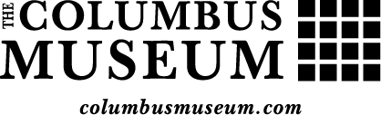

**PERSONAL INFORMATION**

Name:

Address: _______________________________________________________________________________________

City: ___________________________________________________ State: _____________ Zip: ________________

Phone Number: ___________________________________ Cell Phone: ____________________________________

Email: _________________________________________________________________________________________

**AVAILABILITY**

Monday Tuesday Wednesday Thursday Friday Saturday

Preferred Start Date: *(We require a minimum of twelve hours per week for 12 weeks)* Choose department you would like to work with, 1 being your first choice:

Administration Curatorial Design Development Education Marketing & PR

**DEGREE INFORMATION**

Institution: _____________________________________________________________________________________

Major: __________________________________________ Expected Degree Date: __________________________

Dept. Phone: _____________________________________ Advisor: ______________________________________

Awards, honors, scholarships, fellowships received: *(A separate list may be attached if necessary.)*

Special skills: *(Foreign languages, computer technology, publications, etc.)*

**ADDITIONAL REQUIRED MATERIALS:**

Two academic letters of recommendation

Official Transcript

Resume | One essay describing the candidate’s interest in the program

Letters of recommendation should be sent directly to the Columbus Museum from the recommenders.

All materials should be sent to: **bking@comuga.org** or to the following mailing address:

The Columbus Museum

Attn: **Brooke King**

1251 Wynnton Road

Columbus Georgia 31906